The diagram/chart can be printed to be shared with family or health care professionals. Click on the “Print Report” icon. There are two sets of icons, one below the diagram and one below the chart.
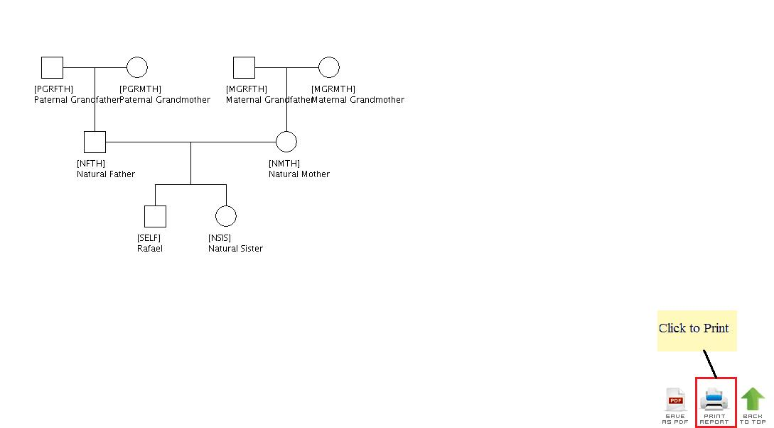

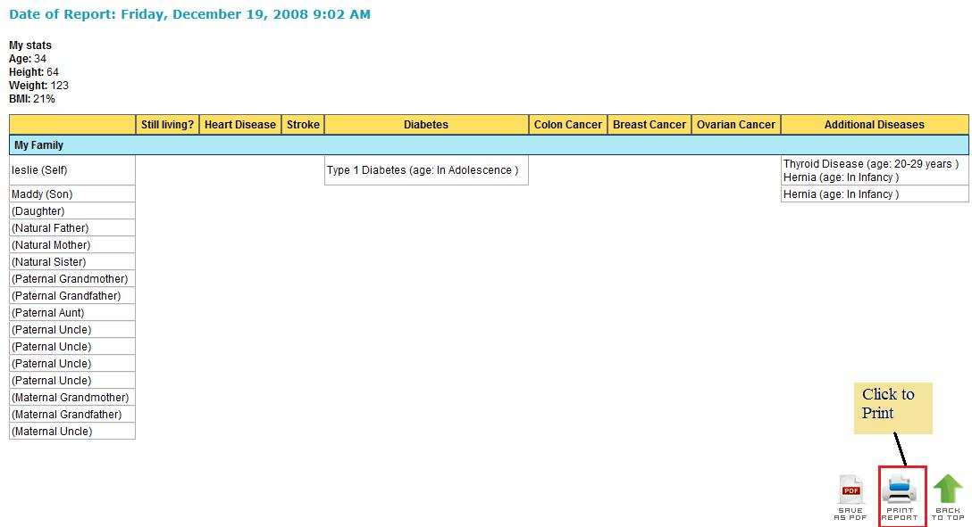

This will open a smaller window. This window is different for the different types of browsers. Select the appropriate printer and then press the OK button. Please see below for the appropriate browser.

Microsoft Internet Explorer 7
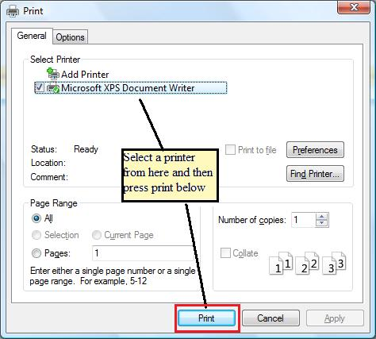

Firefox 3
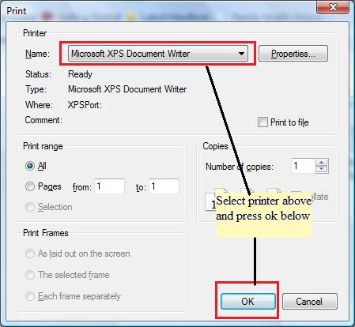

Safari 3.0
